CLASSIFICATION OF DAFFODILS
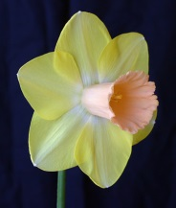  Division 1: Trumpet Daffodil  One flower to a stem; corona (trumpet) as long as, or longer than, the perianth segments (petals) | 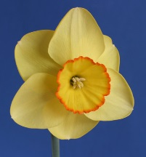  Division 2: Large-cupped (or long-cupped) daffodils  The corona (‘cup’) is more than one-third the length of the perianth segments (petals), but not as long. |  | 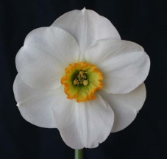  Division 3: Small-cupped (or short-cupped) daffodils  The corona (cup) is not more than one-third the length of the perianth segments (petals).
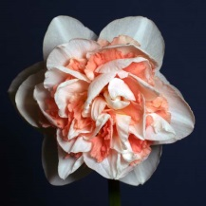  Division 4: Double daffodils  These show doubling of the perianth segments (petals) or the corona (trumpet or cup), or both. | 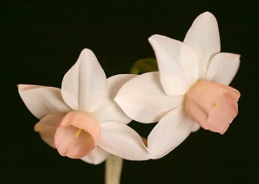  Division 5: Triandrus daffodils  Have the characteristics of Narcissus triandrus clearly evident. There are usually two or more pendant flowers per stem, with perianth segments reflexed |  | 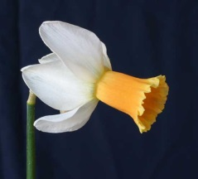  Division 6: Cyclamineus daffodils  Have the characteristics of N. cyclamineus clearly evident. There is usually one flower per stem, with perianth segments well reflexed, and the flower held at an acute angle and with very short neck
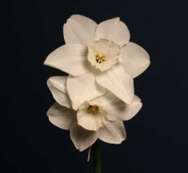  Division 7: Jonquilla and Apodanthus daffodils  Have the characteristics of Sections Jonquillae or Apodanthi clearly evident. There are usually one to five flowers per stem, with perianth segments spreading or reflexed, the corona wide and the flower fragrant | 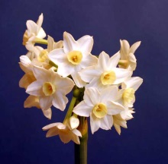  Division 8: Tazetta daffodils  Have the characteristics of Section Tazetta clearly evident. There are usually three to 20 flowers per stem, with strong stem, the perianth segments spreading and the flower fragrant |  | 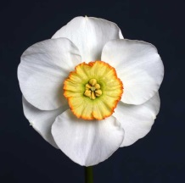  Division 9: Poeticus daffodil  Have the characteristics of the N. poeticus group. There is usually one flower per stem, the perianth segments pure white, the corona short or disc-like and the flower usually fragrant
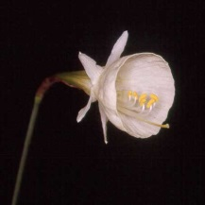  Division 10: Bulbocodium daffodils  Have the characteristics of Section Bulbocodium clearly evident. There is usually one flower per stem, the perianth segments are insignificant and anthers centrally attached to filament. | 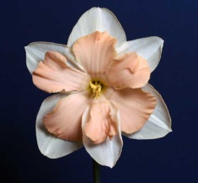  Division 11: Split-corona daffodils  The corona is split. | 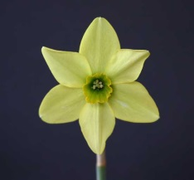  Division 12: Other daffodils  Those that do not fit the description of any other Divisions. |  | 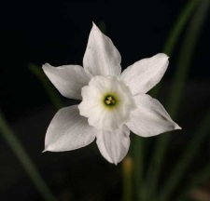  Division 13: Wild types  These are the species, naturally occurring hybrids, etc. (or “daffodil distinguished solely by botanical name”).

